Advanced microprocessor Systems

Assignment by Group 1

Group members:
Abey Alex, Abhishek PU, Abin Xavier, Aby Sebastian, Aeisal Dominic, Ajai Augustine, Albin Thurackal, Alisha Jose, Alphonsa Devassia and Alwin James

INDEX
Part A
Q1. List the features of 8279
Q2. What are the operational modes of 8255?
Q4. What are the features of ADC?
Q5. What are the advantages of using memory segmentation?
Q6. Draw the bit pattern of 8086 flag register and show their significance.

Q7. Explain PUSH and POP Instructions
Q8. Give the responses of CMPS, SCAS, LODS, and STOS

Q9. Explain the flag register in Pentium microprocessor?
Q10. State the features of RISC processor.

Part B
Q11. With a functional block diagram, explain the organization and architecture of 8251.
Q12. Draw and explain the internal architecture of 8255?
Q15. With a block diagram, explain the architecture of 8086
Q16. What are the various addressing modes in 8086, explain with examples
Q17. Discuss with example, various data tranfer instructions supported by 8086.
Q18(a). What are the string related instructions in 8086?
(b) Write a program to multiply two unsigned numbers.
Q19. Describe 80836 flag registers with significance of each bit .how does it differ from 8086 flag registers?
Q20. (a) Explain the addressing modes supported by 80386.
(b) Explain the addition features in pentium processor.

ANSWERS:

Q1. List the features of 8279
Ans. 8279 Programmable Keyboard Display Controller

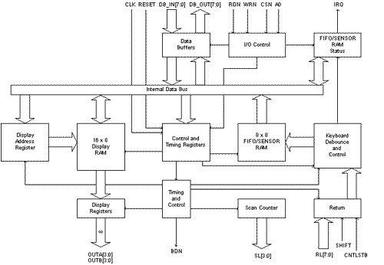

KEYBOARD SECTION

This section has eight lines (RL0-RL7) that can be connected to eight columns of a keyboard, plus two additional lines: Shift and CNTL/STB (Control/Strobe). The status of the SHIFT key and the Control key can be stored along with a key closure. The keys are automatically de-bounced, and the keyboard can operate in two modes: two-key lockout or N-key rollover. In the two-key lockout mode, simultaneous keys are recognized and their codes are stored in the internal buffer; it can also be set up so that no key is recognized until only one key remains pressed.
The keyboard section also includes 8*8 FIFO RAM. The FIFO RAM consists of 8 registers that can store 8 keyboard entries; each is then read in the order of entries. The statues logic keeps track of the number of entries and provides an IRQ (Interrupt Request) signal when the FIFO is not empty.

SCAN SECTION

The scan section has a scan counter and four scan lines (SL0-SL3). These four scan lines can be decoded using a 4-to-16 decoder to generate 16 lines for scanning. These lines can be connected to the rows of a matrix keyboard and the digit drivers of a multiplexed display.

DISPLAY SECTION

The display section has eight output lines divided into two groups A0-A3 and B0-B3. These lines can be used, either as a group of eight lines or as two groups of four, in conjunction with the scan lines for a multiplexed display. The display can be blanked by using the BD line. This section includes 16*8 displays RAM. The MPU can be read from or write into any of these registers.

MPU INTERFACE SECTION

This section includes 8 bidirectional data lines (DB0-DB7), one Interrupt line (IRQ), and 6 lines for interfacing, including the buffer address line (A0).
When A0 is high, signals are interpreted as control words or status; when A0 is low, signals are interpreted as data. The IRQ line goes high whenever data entries are stored in the FIFO. The signal is used to interrupt the MPU to indicate the availability of data.

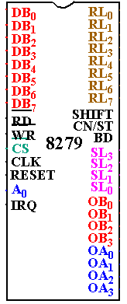

Pin out Definition 8279

- A0: Selects data (0) or control/status (1) for reads and writes between micro and 8279.
- BD: Output that blanks the displays.
- CLK: Used internally for timing. Max is 3 MHz.
- CN/ST: Control/strobe, connected to the control key on the keyboard.
- CS: Chip select that enables programming, reading the keyboard, etc.
- DB7-DB0: Consists of bidirectional pins that connect to data bus on micro.
- IRQ: Interrupt request, becomes 1 when a key is pressed, data is available.
- OUT A3-A0/B3-B0: Outputs that sends data to the most significant/least significant nibble of display.
- RD (WR): Connects to micro's IORC or RD signal, reads data/status registers.
- RESET: Connects to system RESET.
- RL7-RL0: Return lines are inputs used to sense key depression in the keyboard matrix.
- Shift: Shift connects to Shift key on keyboard.
- SL3-SL0: Scan line outputs scan both the keyboard and displays.

Q2. What are the operational modes of 8255?

Ans: There are 3 different operational modes:-

MODE 0

When a port is used for simple input or output operation without handshaking, then it is initialized in Mode 0.If both the ports A and B are used in Mode 0, the port C can be used as an additional port or as an individual 4-bit port.

MODE 1

When a the port A or Port B are used for handshake input or output operation, then the port is initialized in Mode 1. In this mode, some of the pins of port C are used as handshaking lines.
Port Mode Handshake lines
A Input PC0, PC1, PC2
A Output PC0, PC1, PC2
B Input PC3, PC4, PC5
B Output PC3, PC6, PC7

MODE 2

Only port A can be initialized in Mode 2. In mode 2, the port A is used for bidirectional data transfer. The data can output or input on the same eight lines. Then, PC3-PC7 are as handshake lines for Port A. The other Port c lines are used for I/O if port B is initialized in Mode 0 or as handshaking signals if Port B is in Mode 1.

Port address is determined by CS, A1 and A0 lines. CS goes low when A7=1 & A2- A6 are zero.

CS  A7 A6 A5 A4 A3 A2 | A1 A0 | Hex Address | Port
1 0 0 0 0 0 0 0  1 0 0 0 0 0 0 0  1 0 0 0 0 0 0 0  1 0 0 0 0 0 0 0 | 0 0  0 1  1 0  1 1 | 80 H  81 H  82 H  83 H | A  B  C  Control register

Q4. What are the features of ADC?

An analog-to-digital converter (abbreviated ADC, A/D or A to D) is a device which converts continuous signals to discrete digital numbers. The reverse operation is performed by a digital-to-analog converter (DAC).
Typically, an ADC is an electronic device that converts an input analog voltage (or current) to a digital number. However, some non-electronic or only partially electronic devices, such as rotary encoders, can also be considered ADCs. The digital output may use different coding schemes, such as binary, Gray code or two's complement binary.
Features
Resolution
The resolution of the converter indicates the number of discrete values it can produce over the range of analog values. The values are usually stored electronically in binary form, so the resolution is usually expressed in bits. In consequence, the number of discrete values available, or "levels", is usually a power of two. For example, an ADC with a resolution of 8 bits can encode an analog input to one in 256 different levels, since 28 = 256. The values can represent the ranges from 0 to 255 (i.e. unsigned integer) or from -128 to 127 (i.e. signed integer), depending on the application.
Resolution can also be defined electrically, and expressed in volts. The voltage resolution of an ADC is equal to its overall voltage measurement range divided by the number of discrete intervals as in the formula:
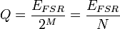
Where:
Q is resolution in volts per step (volts per output code),
EFSR is the full scale voltage range = VRefHi − VRefLo,
M is the ADC's resolution in bits, and
N is the number of intervals, given by the number of available levels (output codes), which is: N = 2M
Response type
Linear ADCs
Most ADCs are of a type known as linear[1] The term linear as used here means that the range of the input values that map to each output value has a linear relationship with the output value, i.e., that the output value k is used for the range of input values from
m(k + b)
to
m(k + 1 + b),
where m and b are constants. Here b is typically 0 or −0.5. When b = 0, the ADC is referred to as mid-rise, and when b = −0.5 it is referred to as mid-tread.
Non-linear ADCs
If the probability density function of a signal being digitized is uniform, then the signal-to-noise ratio relative to the quantization noise is the best possible. Because this is often not the case, it's usual to pass the signal through its cumulative distribution function (CDF) before the quantization. This is good because the regions that are more important get quantized with a better resolution. In the dequantization process, the inverse CDF is needed.
This is the same principle behind the companders used in some tape-recorders and other communication systems, and is related to entropy maximization.
For example, a voice signal has a Laplacian distribution. This means that the region around the lowest levels, near 0, carries more information than the regions with higher amplitudes. Because of this, logarithmic ADCs are very common in voice communication systems to increase the dynamic range of the representable values while retaining fine-granular fidelity in the low-amplitude region.
An eight-bit a-law or the μ-law logarithmic ADC covers the wide dynamic range and has a high resolution in the critical low-amplitude region, that would otherwise require a 12-bit linear ADC.
Accuracy
An ADC has several sources of errors. Quantization error and (assuming the ADC is intended to be linear) non-linearity is intrinsic to any analog-to-digital conversion. There is also a so-called aperture error which is due to a clock jitter and is revealed when digitizing a time-variant signal (not a constant value).
These errors are measured in a unit called the LSB, which is an abbreviation for least significant bit. In the above example of an eight-bit ADC, an error of one LSB is 1/256 of the full signal range, or about 0.4%.
Quantization error
Quantization error is due to the finite resolution of the ADC, and is an unavoidable imperfection in all types of ADC. The magnitude of the quantization error at the sampling instant is between zero and half of one LSB.
In the general case, the original signal is much larger than one LSB. When this happens, the quantization error is not correlated with the signal, and has a uniform distribution. Its RMS value is the standard deviation of this distribution, given by 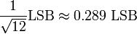. In the eight-bit ADC example, this represents 0.113% of the full signal range.
At lower levels the quantizing error becomes dependent of the input signal, resulting in distortion. This distortion is created after the anti-aliasing filter, and if these distortions are above 1/2 the sample rate they will alias back into the audio band. In order to make the quantizing error independent of the input signal, noise with an amplitude of 1 quantization step is added to the signal. This slightly reduces signal to noise ratio, but completely eliminates the distortion. It is known as dither.
Non-linearity
All ADCs suffer from non-linearity errors caused by their physical imperfections, resulting in their output to deviate from a linear function (or some other function, in the case of a deliberately non-linear ADC) of their input. These errors can sometimes be mitigated by calibration, or prevented by testing.
Important parameters for linearity are integral non-linearity (INL) and differential non-linearity (DNL). These non-linearities reduce the dynamic range of the signals that can be digitized by the ADC, also reducing the effective resolution of the ADC.
Sampling rate
The analog signal is continuous in time and it is necessary to convert this to a flow of digital values. It is therefore required to define the rate at which new digital values are sampled from the analog signal. The rate of new values is called the sampling rate or sampling frequency of the converter.
A continuously varying bandlimited signal can be sampled (that is, the signal values at intervals of time T, the sampling time, are measured and stored) and then the original signal can be exactly reproduced from the discrete-time values by an interpolation formula. The accuracy is limited by quantization error. However, this faithful reproduction is only possible if the sampling rate is higher than twice the highest frequency of the signal. This is essentially what is embodied in the Shannon-Nyquist sampling theorem.
Since a practical ADC cannot make an instantaneous conversion, the input value must necessarily be held constant during the time that the converter performs a conversion (called the conversion time). An input circuit called a sample and hold performs this task—in most cases by using a capacitor to store the analog voltage at the input, and using an electronic switch or gate to disconnect the capacitor from the input. Many ADC integrated circuits include the sample and hold subsystem internally.
Aliasing
All ADCs work by sampling their input at discrete intervals of time. Their output is therefore an incomplete picture of the behaviour of the input. There is no way of knowing, by looking at the output, what the input was doing between one sampling instant and the next. If the input is known to be changing slowly compared to the sampling rate, then it can be assumed that the value of the signal between two sample instants was somewhere between the two sampled values. If, however, the input signal is changing fast compared to the sample rate, then this assumption is not valid.
If the digital values produced by the ADC are, at some later stage in the system, converted back to analog values by a digital to analog converter or DAC, it is desirable that the output of the DAC be a faithful representation of the original signal. If the input signal is changing much faster than the sample rate, then this will not be the case, and spurious signals called aliases will be produced at the output of the DAC. The frequency of the aliased signal is the difference between the signal frequency and the sampling rate. For example, a 2 kHz sinewave being sampled at 1.5 kHz would be reconstructed as a 500 Hz sinewave. This problem is called aliasing.
To avoid aliasing, the input to an ADC must be low-pass filtered to remove frequencies above half the sampling rate. This filter is called an anti-aliasing filter, and is essential for a practical ADC system that is applied to analog signals with higher frequency content.
Although aliasing in most systems is unwanted, it should also be noted that it can be exploited to provide simultaneous down-mixing of a band-limited high frequency signal (see frequency mixer).
Dither
In A to D converters, performance can usually be improved using dither. This is a very small amount of random noise (white noise) which is added to the input before conversion. Its amplitude is set to be about half of the least significant bit. Its effect is to cause the state of the LSB to randomly oscillate between 0 and 1 in the presence of very low levels of input, rather than sticking at a fixed value. Rather than the signal simply getting cut off altogether at this low level (which is only being quantized to a resolution of 1 bit), it extends the effective range of signals that the A to D converter can convert, at the expense of a slight increase in noise - effectively the quantization error is diffused across a series of noise values which is far less objectionable than a hard cutoff. The result is an accurate representation of the signal over time. A suitable filter at the output of the system can thus recover this small signal variation.
An audio signal of very low level (with respect to the bit depth of the ADC) sampled without dither sounds extremely distorted and unpleasant. Without dither the low level always yields a '1' from the A to D. With dithering, the true level of the audio is still recorded as a series of values over time, rather than a series of separate bits at one instant in time.
A virtually identical process, also called dither or dithering, is often used when quantizing photographic images to a fewer number of bits per pixel—the image becomes noisier but to the eye looks far more realistic than the quantized image, which otherwise becomes banded. This analogous process may help to visualize the effect of dither on an analogue audio signal that is converted to digital.
Dithering is also used in integrating systems such as electricity meters. Since the values are added together, the dithering produces results that are more exact than the LSB of the analog-to-digital converter.
Note that dither can only increase the resolution of a sampler, it cannot improve the linearity, and thus accuracy does not necessarily improve.
Oversampling
Usually, signals are sampled at the minimum rate required, for economy, with the result that the quantization noise introduced is white noise spread over the whole pass band of the converter. If a signal is sampled at a rate much higher than the Nyquist frequency and then digitally filtered to limit it to the signal bandwidth then there are 3 main advantages:
digital filters can have better properties (sharper rolloff, phase) than analogue filters, so a sharper anti-aliasing filter can be realised and then the signal can be down sampled giving a better result
a 20 bit ADC can be made to act as a 24 bit ADC with 256x over sampling
the signal-to-noise ratio due to quantization noise will be higher than if the whole available band had been used. With this technique, it is possible to obtain an effective resolution larger than that provided by the converter alone

Q5. What are the advantages of using memory segmentation?
Since the 8086/88 has only 16-bit registers, its Mega (2²⁰) byte of address space is split into segments - logical units of memory that may be up to 64K (2¹⁶) bytes long. Each segment is made up of contiguous memory locations and is an independent, seperately-addressible unit. Every segment is assigned (by software) a base address, which is its starting location in the memory space. Apart from having to begin on 16-byte memory boundaries, there are no restrictions on segment locations.
Physical Address Generation
Every memory location has two kinds of address - physical and logical. A physical address is the 20-bit value that uniquely identifies each byte location in the Megabyte memory space. These may range from 0 to FFFFF Hex. All exchanges between the CPU and memory components use this physical address.
Programs deal with logical, rather than physical, addresses. A logical address consists of a segment base value and an offset value. For any given memory location, the segment base value locates the first byte of the containing segment and the offset value is the distance, in bytes, of the target location from the beginning of the segment. Segment base and offset values are unsigned 16-bit quantities; the lowest-addressed byte in a segment has an offset of 0. Whenever memory is accessed, a physical address is generated from a logical address. This is done by shifting the segment base value four bit positions to the left (hence 16 (2⁴) -byte boundaries) and adding the offset, as illustrated.
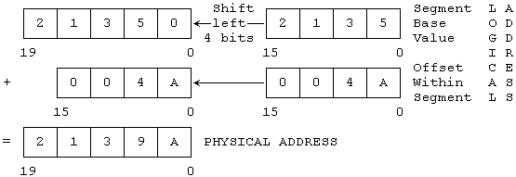
So Logical Address 2135:4A corresponds to Physical Address 2139A
The main advantages of segmented memory:
1)Allows memory capacity to be 1MB although the actual address to be handled are of 16 bit size.
2)Allows the placing of code ,data and stack portions of same program in different parts of memory,for data and code protection.
3)permits a program and its data to be put in different areas of memory each time the program is executed.i.e. provision for relocation is done.

Q6. Draw the bit pattern of 8086 flag register and show their significance.

8086 has a 16-bit flag register which is divided into two parts , viz (a) conditon code or status
flags and (b) machine control flags.The condition code flag register is the lower byte of the
16-bit flag register,with an additional overflow flag,which is not present in 8085.This part of the
flag register of 8086 reflects the results of the operations performed by the ALU.The control
flag register is the higher byte of the flag register of 8086.It contails three flags,viz.
direction flag(D) ,interrupt flag(I) and trap flag(T) .

The complete bit configuration of 8086 flag register is shown below,

The description of each flag bit is as follows ,

S-Sign flag This flag is set ,when the result of any computation is negative .For signed
computatiions ,the sign flag equals the MSB of the result.

Z-Zerp Flag This flag is set, if the result of the computations or comparisons performed by
the previous instruction/instructions is zero.

P-Parity Flag This flag is set to 1,if the lower byte of the result contains even number of 1s.
C-Carry Flag This flag is set ,when there is a carry out of MSB in case addition or a
borrow in case of subtraction.For example ,when two numbers are added ,a carry may be
generated out of the most significant bit position.The carry flag ,in this case ,will be set to
1. In case ,no carry is generated ,i will be 0.Some other instructions also effect or use this
flag.

T-Trap Flag If this flag is set ,the processor enters the single step execution mode . In other
words,a trap interrupt is generated after execution of each instruction.The processor
executes the current instruction and the control is transffered to the trap interrupt service
routine.

I-Interrupt Flag If this flag is set ,the maskable interrupts are recongnised by the CPU,
other wise ,they are ignored .

D-Direction Flag.This is used by string manipulation instructions.If this flag bit is 0,the
string is processed beginning from the lowest address to the highest address ,i.e,
autoincrementing mode.Otherwise,the string is processed from the highest address towards
th lowest address ,i.. autodecrementing mode.

AC-Auxiliary Carry Flag This is set,if there is a carry from th lowst nibble,i.e. bit three,
during addition of borrow for the lowest nibble ,i.e. bit three , during subtraction.

O-Ovrflow Flag This flag is set,if an over flow occurs ,i.e. if the result of a signed operations
is large enough to be accommodatd in a destination register,For example , in case of the
addition of two signed numbers ,if the result overflows into the sign bit,i.e. the result is of more
than 7-bits in size in case of 8-bit signed operations and more than 15-bits in size in case
of 16-bit signed operations, then the overflow flag will be set.

Q7. Explain PUSH and POP Instructions

Push and pop are the two instructions used for stack operations. push instruction is used to insert new element to the stack and pop instruction is used to get a data element from the stack. Stack is a linear data structure in which elements are inserted and deleted in LIFO format

Push instruction : The push instruction pushes a value onto the stack. The value is put ON TOP of the stack. The stack's size will increase by one
Pop instruction : The pop instruction takes the TOP VALUE from the stack and assigns it to the specified variable. The stack's size will decrease by one. If there are no values on the stack (e.g. the stack's size is equal to zero), then the error flag will be set.

The 80x86 push and pop instructions manipulate data on the 80x86's hardware stack. There are 19 varieties of the push and pop instructions, they are
push reg16
pop reg16
push reg32 (3)
pop reg32 (3)
push segreg
pop segreg (except CS)
push memory
pop memory
push immediate_data (2)
pusha (2)
popa (2)
pushad (3)
popad (3)
pushf
popf
pushfd (3)
popfd (3)
enter imm, imm (2)
leave (2)

(2)- Available only on 80286 and later processors.
(3)- Available only on 80386 and later processors.
The first two instructions push and pop a 16 bit general purpose register. This is a compact (one byte) version designed specifically for registers. Note that there is a second form that provides a mod-reg-r/m byte that could push registers as well; most assemblers only use that form for pushing the value of a memory location.
The second pair of instructions push or pop an 80386 32 bit general purpose register. This is really nothing more than the push register instruction described in the previous paragraph with a size prefix byte.
The third pair of push/pop instructions let you push or pop an 80x86 segment register. Note that the instructions that push fs and gs are longer than those that push cs, ds, es, and ss, see Appendix D for the exact details. You can only push the cs register (popping the cs register would create some interesting program flow control problems).
The fourth pair of push/pop instructions allow you to push or pop the contents of a memory location. On the 80286 and earlier, this must be a 16 bit value. For memory operations without an explicit type (e.g., [bx]) you must either use the pushw mnemonic or explicitly state the size using an instruction like push word ptr [bx]. On the 80386 and later you can push and pop 16 or 32 bit values. You can use dword memory operands, you can use the pushd mnemonic, or you can use the dword ptr operator to force 32 bit operation. Examples:
push DblWordVar
push dword ptr [bx]
pushd dword
The pusha and popa instructions (available on the 80286 and later) push and pop all the 80x86 16 bit general purpose registers. Pusha pushes the registers in the following order: ax, cx, dx, bx, sp, bp, si, and then di. Popa pops these registers in the reverse order. Pushad and Popad (available on the 80386 and later) do the same thing on the 80386's 32 bit register set. Note that these "push all" and "pop all" instructions do not push or pop the flags or segment registers.
The pushf and popf instructions allow you to push/pop the processor status register (the flags). Note that these two instructions provide a mechanism to modify the 80x86's trace flag. See the description of this process earlier in this chapter. Of course, you can set and clear the other flags in this fashion as well. However, most of the other flags you'll want to modify (specifically, the condition codes) provide specific instructions or other simple sequences for this purpose.
Enter and leave push/pop the bp register and allocate storage for local variables on the stack. You will see more on these instructions in a later chapter. This chapter does not consider them since they are not particularly useful outside the context of procedure entry and exit.
"So what do these instructions do?" you're probably asking by now. The push instructions move data onto the 80x86 hardware stack and the pop instructions move data from the stack to memory or to a register. The following is an algorithmic description of each instruction:
push instructions (16 bits):
SP := SP - 2
[SS:SP] := 16 bit operand (store result at location SS:SP.)

pop instructions (16 bits):
16-bit operand := [SS:SP]
SP := SP + 2

push instructions (32 bits):
SP := SP - 4
[SS:SP] := 32 bit operand

pop instructions (32 bits):
32 bit operand := [SS:SP]
SP := SP + 4
You can treat the pusha/pushad and popa/popad instructions as equivalent to the corresponding sequence of 16 or 32 bit push/pop operations (e.g., push ax, push cx, push dx, push bx, etc.).
Notice three things about the 80x86 hardware stack. First, it is always in the stack segment (wherever ss points). Second, the stack grows down in memory. That is, as you push values onto the stack the CPU stores them into successively lower memory locations. Finally, the 80x86 hardware stack pointer (ss:sp) always contains the address of the value on the top of the stack (the last value pushed on the stack).
You can use the 80x86 hardware stack for temporarily saving registers and variables, passing parameters to a procedure, allocating storage for local variables, and other uses. The push and pop instructions are extremely valuable for manipulating these items on the stack. You'll get a chance to see how to use them later in this text.
Most of the push and pop instructions do not affect any of the flags in the 80x86 processor status register. The popf/popfd instructions, by their very nature, can modify all the flag bits in the 80x86 processor status register (flags register). Pushf and pushfd push the flags onto the stack, but they do not change any flags while doing so.
All pushes and pops are 16 or 32 bit operations. There is no (easy) way to push a single eight bit value onto the stack. To push an eight bit value you would need to load it into the H.O. byte of a 16 bit register, push that register, and then add one to the stack pointer. On all processors except the 8088, this would slow future stack access since sp now contains an odd address, misaligning any further pushes and pops. Therefore, most programs push or pop 16 bits, even when dealing with eight bit values.
Although it is relatively safe to push an eight bit memory variable, be careful when popping the stack to an eight bit memory location. Pushing an eight bit variable with push word ptr ByteVar pushes two bytes, the byte in the variable ByteVar and the byte immediately following it. Your code can simply ignore the extra byte this instruction pushes onto the stack. Popping such values is not quite so straight forward. Generally, it doesn't hurt if you push these two bytes. However, it can be a disaster if you pop a value and wipe out the following byte in memory. There are only two solutions to this problem. First, you could pop the 16 bit value into a register like ax and then store the L.O. byte of that register into the byte variable. The second solution is to reserve an extra byte of padding after the byte variable to hold the whole word you will pop. Most programs use the former approach
Q8. Give the responses of
- CMPS
- SCAS
- LODS
- STOS

CMPS
Compare string byte or string word:
This instruction can be used to compare two strings of bytes or words. The length
Of the string is stored in register Cx. If both the bytes or string words are equal,zero flag is set. The DS:SI and ES:DI points to the two strings. The REP instruction is used to repeat the operation till Cx becomes zero.

SCAS
Scan string byte or string word:
This instruction scans a string of bytes or words for an operand byte or word specified in the register Al or Ax. The string is pointed by ES:DI register pair. The length of the string is stored in Cx. Whenever a match to the specified operand is found,the excecution stops and zero flag is set. if no match is found zero flag is reset.
LODS:
Load string byte or string word
This instruction loads the AL or Ax registers by the content of the string pointed to by the DS:SI register pair. The SI is modified automatically depending upon DF. If it is a byte transfer(LODSB),the SI is modified by one and if it is a word transfer(LODSW),the SI is modified by two. No other flags are affected by this instruction.
STOS:
This instruction stores the Al or Ax registers contents to a location in the string pointed by ES:DI pair. The DI register is modified automatically. No flags are affected by this instruction. The direction flag controls the string instruction excecution. The source index SI and the destination ndex DI are modified after each iteration automatically. If DF =1,then the excecution follows autodecrement mode. Hence,in auto decrementing mode,the strings are referred to by their end addresses. If DF=0,then auto incrementing mode.

Q9. Explain the flag register in Pentium microprocessor?

Flags Register
The 32-bit register flags register EFLAG is an extension of the 16-bit flag register in 8086 and 80286. The low-order 16 bits of EFLAGS are named FLAGS for compatibility with older 8086 and 80286 code. There are three basic groups of flags, status flags, control flags and the system flags. The flags are as follows:
The status flags used by application programmers are CF, PF, AF, ZF, SF, and OF. These flags hold the results of various instructions that are then used by later instructions.
DF, IF and TF are the control flags of 80286. These flags control the processor actions or action of certain instructions.
System flags in EFLAG are RF, NT, IOPL and VM.

Intel Reserved | VM | RF | 0 | NT | IOPL | OF | DF | IF | TF | SF | ZF | 0 | AF | 0 | PF | 1 | CF

31 17 16 15 14 13 12 11 10 9 8 7 6 5 4 3 2 1 0

RF: Resume flag is used with debug register break pointer. It is checked at the starting of every instruction cycle and if it is set, the debug fault can be ignored during that instruction cycle.

Q10. State the features of RISC processor.

- Simple instruction set : In a RISC machine, the instruction set contains simple, basic instructions, from which more complex instructions can be composed.

- Same length instruction : Each instruction is of the same length, so that it may be fetched in a single operation.

- Single machine-cycle instructions : Most instructions complete in one machine cycle, which allows the processor to handle several instructions at the same time.

- Pipelining : Usually massive pipelining is embedded in a RISC processor.

- Very few addressing modes and formats : Unlike the CISC processors, where the number of addressing modes are very high, in RISC processors, the addressing modes are much less and it supports few formats.

- Large number of registers : The RISC design philosophy generally incorporates a large number of registers to prevent large amounts of interactions with memory.

- Microcoding not required: Unlike in a CISC machine , in RISC architecture, instruction microcoding is not required.

- Load and store architecture: The RISC architeture is primarily a load and store architecture, implying that all the memory accesses take place using load or store type operations.

Q11. With a functional block diagram, explain the organization and architecture of 8251.

8251 UNIVERSAL SYNCHRONOUS ASYNCHRONOUS RECEIVER TRANSMITTER (USART)

The 8251 is a USART (Universal Synchronous Asynchronous Receiver Transmitter) for serial data communication. As a peripheral device of a microcomputer system, the 8251 receives parallel data from the CPU and transmits serial data after conversion. This device also receives serial data from the outside and transmits parallel data to the CPU after conversion.
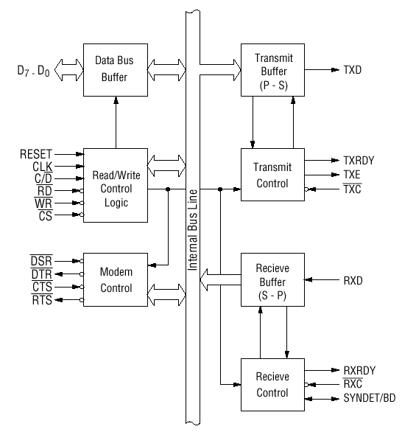
Block diagram of the 8251 USART (Universal Synchronous Asynchronous Receiver Transmitter)

The 8251 functional configuration is programmed by software. Operation between the 8251 and a CPU is executed by program control. Table 1 shows the operation between a CPU and the device.
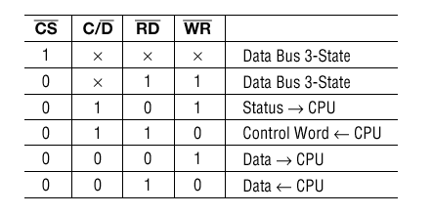
Table 1 Operation between a CPU and 8251

Control Words

There are two types of control word.
1. Mode instruction (setting of function)
2. Command (setting of operation)

  - Mode Instruction

Mode instruction is used for setting the function of the 8251. Mode instruction will be in "wait for write" at either internal reset or external reset. That is, the writing of a control word after resetting will be recognized as a "mode instruction."
Items set by mode instruction are as follows:
• Synchronous/asynchronous mode
• Stop bit length (asynchronous mode)
• Character length
• Parity bit
• Baud rate factor (asynchronous mode)
• Internal/external synchronization (synchronous mode)
• Number of synchronous characters (Synchronous mode)

The bit configuration of mode instruction is shown in Figures 2 and 3. In the case of synchronous mode, it is necessary to write one-or two byte sync characters. If sync characters were written, a function will be set because the writing of sync characters constitutes part of mode instruction.
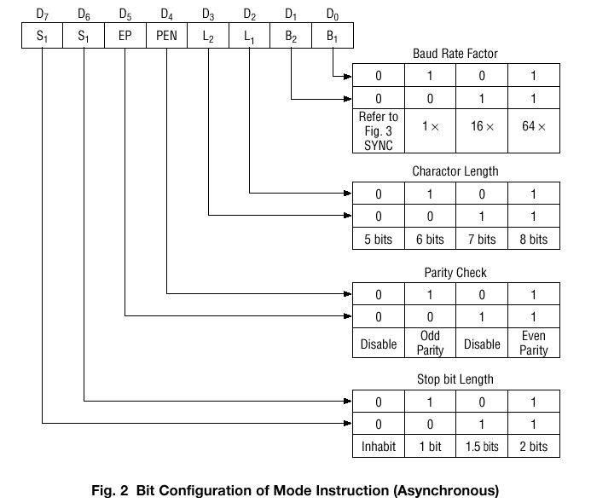

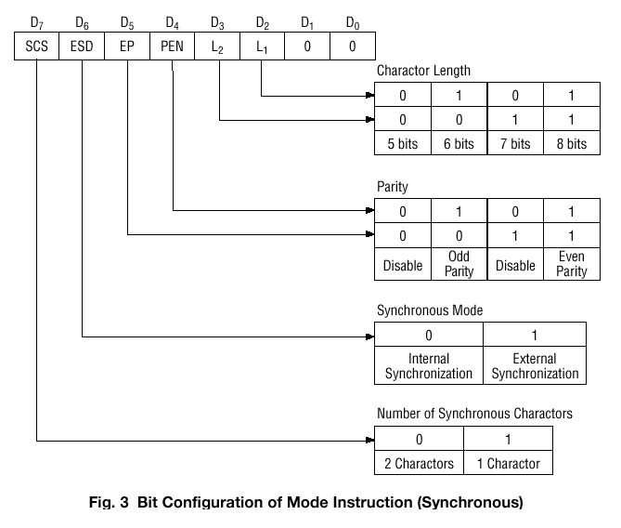

2) Command

Command is used for setting the operation of the 8251. It is possible to write a command whenever necessary after writing a mode instruction and sync characters.
Items to be set by command are as follows:
• Transmit Enable/Disable
• Receive Enable/Disable
• DTR, RTS Output of data.
• Resetting of error flag.
• Sending to break characters
• Internal resetting
• Hunt mode (synchronous mode)

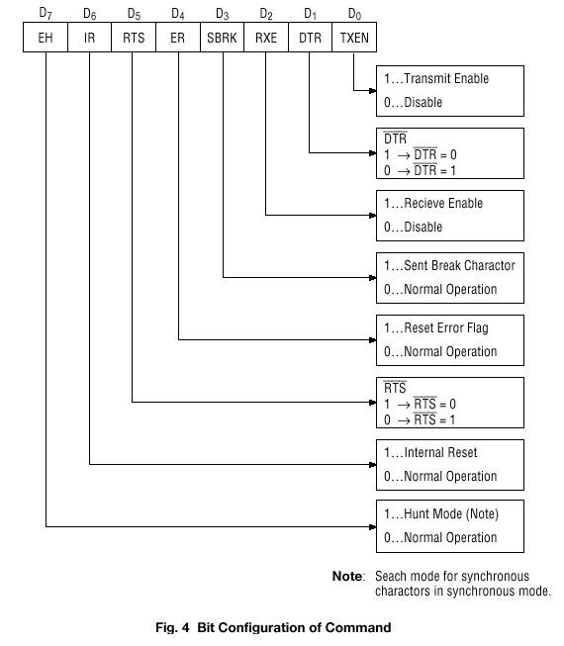

Status Word

It is possible to see the internal status of the 8251 by reading a status word. The bit configuration of status word is shown in Fig. 5.
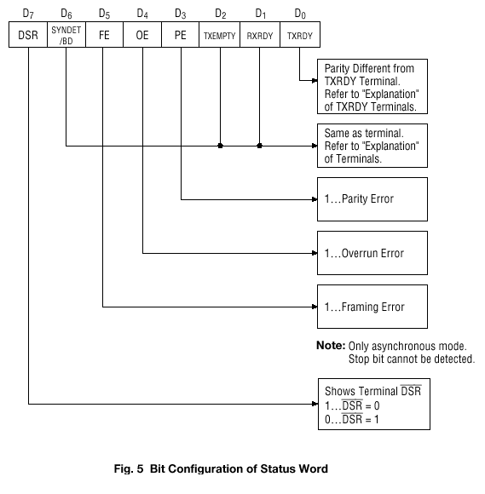

Pin Description

D 0 to D 7 (l/O terminal)

This is bidirectional data bus which receive control words and transmits data from the CPU and sends status words and received data to CPU.

RESET (Input terminal)

A "High" on this input forces the 8251 into "reset status." The device waits for the writing of "mode instruction." The min. reset width is six clock inputs during the operating status of CLK.

CLK (Input terminal)

CLK signal is used to generate internal device timing. CLK signal is independent of RXC or TXC. However, the frequency of CLK must be greater than 30 times the RXC and TXC at Synchronous mode and Asynchronous "x1" mode, and must be greater than 5 times at Asynchronous "x16" and "x64" mode.

WR (Input terminal)

This is the "active low" input terminal which receives a signal for writing transmit data and control words from the CPU into the 8251.

RD (Input terminal)

This is the "active low" input terminal which receives a signal for reading receive data and status words from the 8251.

C/D (Input terminal)

This is an input terminal which receives a signal for selecting data or command words and status words when the 8251 is accessed by the CPU. If C/D = low, data will be accessed. If C/D = high, command word or status word will be accessed.

CS (Input terminal)

This is the "active low" input terminal which selects the 8251 at low level when the CPU accesses. Note: The device won’t be in "standby status"; only setting CS = High.

TXD (output terminal)

This is an output terminal for transmitting data from which serial-converted data is sent out. The device is in "mark status" (high level) after resetting or during a status when transmit is disabled. It is also possible to set the device in "break status" (low level) by a command.

TXRDY (output terminal)

This is an output terminal which indicates that the 8251is ready to accept a transmitted data character. But the terminal is always at low level if CTS = high or the device was set in "TX disable status" by a command. Note: TXRDY status word indicates that transmit data character is receivable, regardless of CTS or command. If the CPU writes a data character, TXRDY will be reset by the leading edge or WR signal.

TXEMPTY (Output terminal)

This is an output terminal which indicates that the 8251 has transmitted all the characters and had no data character. In "synchronous mode," the terminal is at high level, if transmit data characters are no longer remaining and sync characters are automatically transmitted. If the CPU writes a data character, TXEMPTY will be reset by the leading edge of WR signal. Note : As the transmitter is disabled by setting CTS "High" or command, data written before disable will be sent out. Then TXD and TXEMPTY will be "High". Even if a data is written after disable, that data is not sent out and TXE will be "High".After the transmitter is enabled, it sent out. (Refer to Timing Chart of Transmitter Control and Flag Timing)

TXC (Input terminal)

This is a clock input signal which determines the transfer speed of transmitted data. In "synchronous mode," the baud rate will be the same as the frequency of TXC. In "asynchronous mode", it is possible to select the baud rate factor by mode instruction. It can be 1, 1/16 or 1/64 the TXC. The falling edge of TXC sifts the serial data out of the 8251.

RXD (input terminal)

This is a terminal which receives serial data.

RXRDY (Output terminal)

This is a terminal which indicates that the 8251 contains a character that is ready to READ. If the CPU reads a data character, RXRDY will be reset by the leading edge of RD signal. Unless the CPU reads a data character before the next one is received completely, the preceding data will be lost. In such a case, an overrun error flag status word will be set.

RXC (Input terminal)

This is a clock input signal which determines the transfer speed of received data. In "synchronous mode," the baud rate is the same as the frequency of RXC. In "asynchronous mode," it is possible to select the baud rate factor by mode instruction. It can be 1, 1/16, 1/64 the RXC.

SYNDET/BD (Input or output terminal)

This is a terminal whose function changes according to mode. In "internal synchronous mode." this terminal is at high level, if sync characters are received and synchronized. If a status word is read, the terminal will be reset. In "external synchronous mode, "this is an input terminal. A "High" on this input forces the 8251 to start receiving data characters.
In "asynchronous mode," this is an output terminal which generates "high level” output upon the detection of a "break" character if receiver data contains a "low-level" space between the stop bits of two continuous characters. The terminal will be reset, if RXD is at high level. After Reset is active, the terminal will be output at low level.

DSR (Input terminal)

This is an input port for MODEM interface. The input status of the terminal can be recognized by the CPU reading status words.

DTR (Output terminal)

This is an output port for MODEM interface. It is possible to set the status of DTR by a command.

CTS (Input terminal)

This is an input terminal for MODEM interface which is used for controlling a transmit circuit. The terminal controls data transmission if the device is set in "TX Enable" status by a command. Data is transmittable if the terminal is at low level.

RTS (Output terminal)

This is an output port for MODEM interface. It is possible to set the status RTS by a command.

Q12. Draw and explain the internal architecture of 8255?

8255A is a general purpose, programmable, parallel I/O device. It has 24 I/O pins that can be grouped primarily in two 8-bit parallel ports: A and B, with the remaining eight bits as port C. The eight bits of port C can be used as individual bits or can be grouped in two 4-bit ports: C_{upper} & C_{lower}. The functions of these ports are defined by writing a control word in the control register.

Architecture

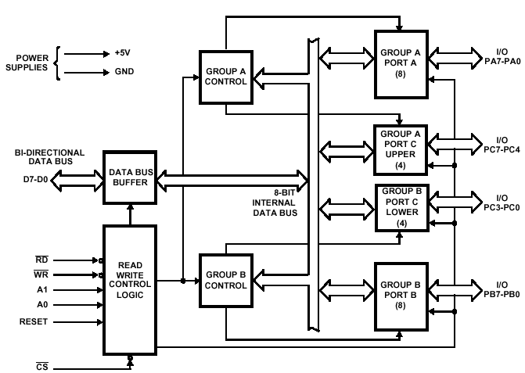

Data Bus Buffer
This three-state bi-directional 8-bit buffer is used to interface the 8255 to the system data bus. Data is transmitted or received by the buffer upon execution of input or output instructions by the CPU. Control words and status information are also transferred through the data bus buffer.

Read/Write and Control Logic
The function of this block is to manage all of the internal and external transfers of both Data and Control or Status words. It accepts inputs from the CPU Address and Control busses and in turn, issues commands to both of the Control Groups.

(CS) Chip Select: A "low" on this input pin enables the communication between the 8255 and the CPU.

(RD) Read: A "low" on this input pin enables 8255 to send the data or status information to the CPU on the data bus. In essence, it allows the CPU to "read from" the 8255.

(WR) Write: A "low" on this input pin enables the CPU to write data or control words into the 8255.

(A0 and A1) Port Select 0 and Port Select 1. These input signals, in conjunction with the RD and WR inputs, control the selection of one of the three ports or the control word register. They are normally connected to the least significant bits of the address bus (A0 and A1).

(RESET) Reset. A "high" on this input initializes the control register to 9Bh and all ports (A, B, C) are set to the input mode.

Group A and Group B Controls
The functional configuration of each port is programmed by the systems software. In essence, the CPU "outputs" a control word to the 8255. The control word contains information such as "mode", "bit set", "bit reset", etc., that initializes the functional configuration of the 8255. Each of the Control blocks (Group A and Group B) accepts "commands" from the Read/Write Control logic, receives "control words" from the internal data bus and issues the proper commands to its associated ports.

Ports A, B, and C
The 8255 contains three 8-bit ports (A, B, and C). All can be configured to a wide variety of functional characteristics by the system software but each has its own special features or "personality" to further enhances the power and flexibility of the 8255.

Port A One 8-bit data output latch/buffer and one 8-bit data input latch. Both "pull-up" and "pull-down" bus-hold devices are present on Port A.

Port B One 8-bit data input/output latch/buffer and one 8-bit data input buffer.

Port C One 8-bit data output latch/buffer and one 8-bit data input buffer (no latch for input). This port can be divided into two 4-bit ports under the mode control. Each 4-bit port contains a 4-bit latch and it can be used for the control signal output and status signal inputs in conjunction with ports A and B.

* Parallel i/o device

* Used for simple i/o to interrupt i/o

* Flexible,versatile and economical

* Compact with any microprocessor

PINS

>>>>24 I/0 PINS(PORT A-8,PORT B-8& PORT C 8)

>>>>PORT C(8) IS GROUPED INTO 4 BIT PORTS

>>>>FUNCTIONS OF PORTS ARE DEFINED BY CONTROL WORD

SIGNALS

>>>>PA7-PA0 >> 8 POTR A LINES THAT ACT AS EITHER LATCHED O/P OR BUFFERED I/P LINES DEPENDING ON THECONTROL WORD GIVEN

>>>>PC7- PC4>>UPPER MIDDLE OF PORT C,.HAND SHAKE FOR MODE 1 & 2.

>>>>PC3 PC0 >> LOWER NIBBLE OF PORT C

>>>>>RD>>WHEN ITS LOW, MP READS DATA FROM THE SELECTED I/O PORT OF 8255

>>WR> WHEN ITS LOW ,DATA IS WRITTEN THROUGH THE SELECTED I/O PORT OF 8255

>>>>CS>> IT ENABLES 8255

>>>>D0- D7 >>DATA BUS LINES THAT CARRY DATA/CONTROL WORDTO OR FROM MP

>>>RESET> WHEN HIGH, IT CLEARS CWR & ALL PORTS SET AS I/O PORTS BY DEFAULT

ARCHITECTURAL DETAILS

>>>>8BIT DATA BUS BUFFER IS CONTROLLED BY READ/WRITE CONTROL LOGIC

>>>>READ/WRITE LOGI MANAGES ALL INTERNAL &EXTERNAL TRANSFER OF DATA

>>>>8 BIT BI DIRECTIONAL BUFFER IS USED TO INTERFACE 8255 INTERNAL DATA BUS WITH EXTERNAL SYSTEM MEMMORY DATA BUS

>>>>THE BUFFER RECIEVES AND TRANSMITS DATA UPON THE EXECUTION OF I/P OR O/P INSTRUCTIONS BY MP

Q15. With a block diagram, explain the architecture of 8086.
Microprocessors generally execute a program by repeatedly cycling through the following steps (this description is somewhat simplified):
- Fetch the next instruction from memory.
- Read an operand (if required by the instruction).
- Execute the instruction.
- Write the result (if required by the instruction).
In previous CPUs, most of these steps have been performed serially, or with only a single bus cycle fetch overlap. The architecture of the 8086 and 8088 CPUs, while performing the same steps, allocates them to two separate processing units within the CPU. The execution unit (EU) executes instructions; the bus interface unit (BIU) fetches instructions, reads operands and writes results.
The two units can operate independently of one another and are able, under most circumstances, to extensively overlap instruction fetch with execution The result is that, in most cases, the time normally required to fetch instructions "disappears" because the EU executes instructions that have already been fetched by the BIU. The Figure illustrates this overlap and compares it with traditional microprocessor operation. In the example, overlapping reduces the elapsed time required to execute three instructions, and allows two additional instructions to be prefetched as well.
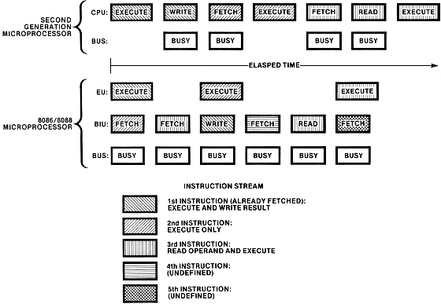

Execution Unit
The execution units of the 8086 and 8088 are identical. A 16-bit arithmetic/logic unit (ALU) in the EU maintains the CPU status and control flags, and manipulates the general registers and instruction operands. All registers and data paths in the EU are 16 bits wide for fast internal transfers.
The EU has no connection to the system bus, the "outside world." It obtains instructions from a queue maintained by the BIU. Likewise, when an instruction requires access to memory or to a peripheral device, the EU requests the BIU to obtain or store the data. All addresses manipulated by the EU are 16 bits wide. The BIU, however, performs an address relocation that gives the EU access to the full megabyte of memory space.

8086 has a 16-bit flag register which is divided into two parts , viz (a) conditon code or status \par
flags and (b) machine control flags.The condition code flag register is the lower byte of the \par
16-bit flag register,with an additional overflow flag,which is not present in 8085.This part of the\par
flag register of 8086 reflects the results of the operations performed by the ALU.The control \par
flag register is the higher byte of the flag register of 8086.It contails three flags,viz. \par
direction flag(D) ,interrupt flag(I) and trap flag(T) .\par
\par
\par
The complete bit configuration of 8086 flag register is shown below,\par
\par
The description of each flag bit is as follows ,\par
\par
\par
S-Sign flag This flag is set ,when the result of any computation is negative .For signed\par
computatiions ,the sign flag equals the MSB of the result.\par
\par
Z-Zerp Flag This flag is set, if the result of the computations or comparisons performed by\par
the previous instruction/instructions is zero.\par
\par
P-Parity Flag This flag is set to 1,if the lower byte of the result contains even number of 1s.\par
C-Carry Flag This flag is set ,when there is a carry out of MSB in case addition or a \par
borrow in case of subtraction.For example ,when two numbers are added ,a carry may be \par
generated out of the most significant bit position.The carry flag ,in this case ,will be set to \par
1. In case ,no carry is generated ,i will be 0.Some other instructions also effect or use this \par
flag.\par
\par
T-Trap Flag If this flag is set ,the processor enters the single step execution mode . In other \par
words,a trap interrupt is generated after execution of each instruction.The processor \par
executes the current instruction and the control is transffered to the trap interrupt service \par
routine.\par
\par
I-Interrupt Flag If this flag is set ,the maskable interrupts are recongnised by the CPU,\par
other wise ,they are ignored .\par
\par
D-Direction Flag.This is used by string manipulation instructions.If this flag bit is 0,the \par
string is processed beginning from the lowest address to the highest address ,i.e,\par
autoincrementing mode.Otherwise,the string is processed from the highest address towards \par
th lowest address ,i.. autodecrementing mode.\par
\par
AC-Auxiliary Carry Flag This is set,if there is a carry from th lowst nibble,i.e. bit three,\par
during addition of borrow for the lowest nibble ,i.e. bit three , during subtraction.\par
\par
O-Ovrflow Flag This flag is set,if an over flow occurs ,i.e. if the result of a signed operations\par
is large enough to be accommodatd in a destination register,For example , in case of the\par
addition of two signed numbers ,if the result overflows into the sign bit,i.e. the result is of more\par
than 7-bits in size in case of 8-bit signed operations and more than 15-bits in size in case \par
of 16-bit signed operations, then the overflow flag will be set.\par
\par
\par
}

Q16. What are the various addressing modes in 8086,explain with examples

Addressing mode indicates away locating data or operands.Depending upon th data
types used in the instruction and the memory addressing modes ,any instruction may
belong to one or more addressing modes,or some instruction may not belong to any of
the addressing modes .Thus the addressing modes describe the types of operands and
the way they are accessd for excuting an instruction.Here,we will present the addressing
modes of the instruction depending upon their types.According to the flow of instructions
execution ,the instructions may be categorised.

Th addressing modes for the sequential control transfer instructions are explained as follows

1.Immediate In this type of addressing ,immediate data is a part of instruction ,and appears in
the form of successive byte or bytes.
eg; MOV AX,0005H

In th above example ,0005H is the immdiate data.The immdiate data may be 8-bit or 16 bit in size.

2.Dircet In this direct addressing mode,a 16-bit memory address offset is directly specified in the
instruction as a part of it.
eg; MOV AX,[5000H].

Here,data resides in a memory location in th data is segment ,whos effective address may be computed
using 5000H as th offst address and content of DS as segment address .Th effcetive address ,here
is 10H* DS + 5000H .

3.Register In register addressing mode,the data is stored in a register and it is reffered and it is reffered
using th particular register.All the registers ,except IP,may be used in this mode.
eg; MOV AX,[BX].

4.Register indirect Some times ,the address of the memory of the locations which contains data or
operands is determined in an indirect mode.In this addressing mode, the offset address of data is in
either BX or SI or DI register .The default segment is either DS or ES .The data is supposd to be
available at the address pointed to by the content of any of the above registers in the default data segment.
eg; MOV AX,[BX].

Here ,data is present in a memory location in DS whose offset address is in BX.The effctive address of the
data is given as 10H*DS + [BX].

5.Indexed In this addressing mode, offset of the operand is stored in one of the index registers.DS and
ES are the default segments for index registers SI and DI respectively. This mode is a special case
of the above discussed register indirect addressing mode.
eg; MOV AX,[SI].

Here ,data is available at an offset address stored in SI in DS .The effctive address, in this case ,
is computed as 10H*DS+[SI].

6.Register relative In this addressing mode ,the data is availble at an effective address formd by adding an
8-bit or 16 bit displacement with the content of any one of the registers BX ,BP ,SI and DI in the default
(either DS or ES) segment .The example given below explains this mode.

eg;MOV AX ,50H[BX].

Here ,the effective address is given as 10H*DS+50H+[BX].

7.Based Indexed The effective address of data is formed ,in this adderssing mode ,by adding
content of base register ( any one of BX or BP) to the content of an index register
(any on of SI or DI) .The default segment register may be ES or DS.

eg;10H*DS + [BX] +[SI].

8.Relative Based Indexed The effective address is formed by adding an 8 or 16 bit displacement with the
effective address of data is computed as 160H*DS +[BX]+[SI]+50H.

9.Intrasegment Direct Mode In this mode ,the address to which the control is to be transferred lies in the same
segment in which the control transfer instruction lies and appears directly in the instructions as immediate
displacement value.In this addressing mode, the displacement is computed relative to the content of the instruction
pointer IP.

10.Intrasegment indirect Mode In this mode,the displacement to which the control is to be transffered ,is the
same segment in which the control transfer instructin lies ,but it is passd to the instruction indirectly.
Here ,the branch address is found as the content of a register or a memory location .This addrssing mode ,may
be used in unconditional branch instrucition.

11.Intersegmnt Direct In this mode ,the address to which the control is to be transffered is in a different segment
to another code segment .This addrssing mode provides a means of branching from one code segment to
another code segment .Here ,the CS and IP of the destination address are specified directly in the instruction

12.Intersegmnt Indirect In this mode,the address to which the control is to be transffered lies in a different
segment and it is passed to the instruction indirectly ,i.e. contents of a memory block containig four bytes ,
i.e. IP (LSB) ,IP( MSB ) ,CS(LSB) and CS (MSB) sequentially .The starting address of the memory block may be reffered
using any of the addressing modes,except immdiate mode.

Q17. Discuss with example, various data tranfer instructions supported by 8086.
.The data movement instructions copy values from one location to another. These instructions include mov, xchg, lds, lea, les, lfs, lgs, lss, push, pusha, pushad, pushf, pushfd, pop, popa, popad, popf, popfd, lahf, and sahf.
The MOV Instruction
The mov instruction takes several different forms:
mov reg, reg
mov mem, reg
mov reg, mem
mov mem, immediate data
mov reg, immediate data
mov ax/al, mem
mov mem, ax/al
mov segreg, mem16
mov segreg, reg16
mov mem16, segreg
mov reg16, segreg
The last chapter discussed the mov instruction in detail, only a few minor comments are worthwhile here. First, there are variations of the mov instruction that are faster and shorter than other mov instructions that do the same job. For example, both the mov ax, mem and mov reg, mem instructions can load the ax register from a memory location. On all processors the first version is shorter. On the earlier members of the 80x86 family, it is faster as well.
There are two very important details to note about the mov instruction. First, there is no memory to memory move operation. The mod-reg-r/m addressing mode byte (see Chapter Four) allows two register operands or a single register and a single memory operand. There is no form of the mov instruction that allows you to encode two memory addresses into the same instruction. Second, you cannot move immediate data into a segment register. The only instructions that move data into or out of a segment register have mod-reg-r/m bytes associated with them; there is no format that moves an immediate value into a segment register. Two common errors beginning programmers make are attempting a memory to memory move and trying to load a segment register with a constant.
The operands to the mov instruction may be bytes, words, or double words. Both operands must be the same size or MASM will generate an error while assembling your program. This applies to memory operands and register operands. If you declare a variable, B, using byte and attempt to load this variable into the ax register, MASM will complain about a type conflict.
The CPU extends immediate data to the size of the destination operand (unless it is too big to fit in the destination operand, which is an error). Note that you can move an immediate value into a memory location. The same rules concerning size apply. However, MASM cannot determine the size of certain memory operands. For example, does the instruction mov [bx], 0 store an eight bit, sixteen bit, or thirty-two bit value? MASM cannot tell, so it reports an error. This problem does not exist when you move an immediate value into a variable you've declared in your program. For example, if you've declared B as a byte variable, MASM knows to store an eight bit zero into B for the instruction mov B, 0. Only those memory operands involving pointers with no variable operands suffer from this problem. The solution is to explicitly tell MASM whether the operand is a byte, word, or double word. You can accomplish this with the following instruction forms:
mov byte ptr [bx], 0
mov word ptr [bx], 0
mov dword ptr [bx], 0 (3)

(3) Available only on 80386 and later processors
For more details on the type ptr operator, see Chapter Eight.
Moves to and from segment registers are always 16 bits; the mod-reg-r/m operand must be 16 bits or MASM will generate an error. Since you cannot load a constant directly into a segment register, a common solution is to load the constant into an 80x86 general purpose register and then copy it to the segment register. For example, the following two instruction sequence loads the es register with the value 40h:
mov ax, 40h
mov es, ax
Note that almost any general purpose register would suffice. Here, ax was chosen arbitrarily.
The mov instructions do not affect any flags. In particular, the 80x86 preserves the flag values across the execution of a mov instruction.
The XCHG Instruction
The xchg (exchange) instruction swaps two values. The general form is
xchg operand1, operand2
There are four specific forms of this instruction on the 80x86:
xchg reg, mem
xchg reg, reg
xchg ax, reg16
xchg eax, reg32 (3)

(3) Available only on 80386 and later processors
The first two general forms require two or more bytes for the opcode and mod-reg-r/m bytes (a displacement, if necessary, requires additional bytes). The third and fourth forms are special forms of the second that exchange data in the (e)ax register with another 16 or 32 bit register. The 16 bit form uses a single byte opcode that is shorter than the other two forms that use a one byte opcode and a mod-reg-r/m byte.
Already you should note a pattern developing: the 80x86 family often provides shorter and faster versions of instructions that use the ax register. Therefore, you should try to arrange your computations so that they use the (e)ax register as much as possible. The xchg instruction is a perfect example, the form that exchanges 16 bit registers is only one byte long.
Note that the order of the xchg's operands does not matter. That is, you could enter xchg mem, reg and get the same result as xchg reg, mem. Most modern assemblers will automatically emit the opcode for the shorter xchg ax, reg instruction if you specify xchg reg, ax.
Both operands must be the same size. On pre-80386 processors the operands may be eight or sixteen bits. On 80386 and later processors the operands may be 32 bits long as well.
The xchg instruction does not modify any flags.
The LDS, LES, LFS, LGS, and LSS Instructions
The lds, les, lfs, lgs, and lss instructions let you load a 16 bit general purpose register and segment register pair with a single instruction. On the 80286 and earlier, the lds and les instructions are the only instructions that directly process values larger than 32 bits. The general form is
LxS dest, source
These instructions take the specific forms:
lds reg16, mem32
les reg16, mem32
lfs reg16, mem32 (3)
lgs reg16, mem32 (3)
lss reg16, mem32 (3)

(3) Available only on 80386 and later processors
Reg16 is any general purpose 16 bit register and mem32 is a double word memory location (declared with the dword statement).
These instructions will load the 32 bit double word at the address specified by mem32 into reg16 and the ds, es, fs, gs, or ss registers. They load the general purpose register from the L.O. word of the memory operand and the segment register from the H.O. word. The following algorithms describe the exact operation:
lds reg16, mem32:
reg16 := [mem32]
ds := [mem32 + 2]
les reg16, mem32:
reg16 := [mem32]
es := [mem32 + 2]
lfs reg16, mem32:
reg16 := [mem32]
fs := [mem32 + 2]
lgs reg16, mem32:
reg16 := [mem32]
gs := [mem32 + 2]
lss reg16, mem32:
reg16 := [mem32]
ss := [mem32 + 2]
Since the LxS instructions load the 80x86's segment registers, you must not use these instructions for arbitrary purposes. Use them to set up (far) pointers to certain data objects as discussed in Chapter Four. Any other use may cause problems with your code if you attempt to port it to Windows, OS/2 or UNIX.
Keep in mind that these instructions load the four bytes at a given memory location into the register pair; they do not load the address of a variable into the register pair (i.e., this instruction does not have an immediate mode). To learn how to load the address of a variable into a register pair, see Chapter Eight.
The LxS instructions do not affect any of the 80x86's flag bits.
The LEA Instruction
The lea (Load Effective Address) instruction is another instruction used to prepare pointer values. The lea instruction takes the form:
lea dest, source
The specific forms on the 80x86 are
lea reg16, mem
lea reg32, mem (3)

(3) Available only on 80386 and later processors.
It loads the specified 16 or 32 bit general purpose register with the effective address of the specified memory location. The effective address is the final memory address obtained after all addressing mode computations. For example, lea ax, ds:[1234h] loads the ax register with the address of memory location 1234h; here it just loads the ax register with the value 1234h. If you think about it for a moment, this isn't a very exciting operation. After all, the mov ax, immediate_data instruction can do this. So why bother with the lea instruction at all? Well, there are many other forms of a memory operand besides displacement-only operands. Consider the following lea instructions:
lea ax, [bx]
lea bx, 3[bx]
lea ax, 3[bx]
lea bx, 4[bp+si]
lea ax, -123[di]
The lea ax, [bx] instruction copies the address of the expression [bx] into the ax register. Since the effective address is the value in the bx register, this instruction copies bx's value into the ax register. Again, this instruction isn't very interesting because mov can do the same thing, even faster.
The lea bx,3[bx] instruction copies the effective address of 3[bx] into the bx register. Since this effective address is equal to the current value of bx plus three, this lea instruction effectively adds three to the bx register. There is an add instruction that will let you add three to the bx register, so again, the lea instruction is superfluous for this purpose.
The third lea instruction above shows where lea really begins to shine. lea ax, 3[bx] copies the address of the memory location 3[bx] into the ax register; i.e., it adds three with the value in the bx register and moves the sum into ax. This is an excellent example of how you can use the lea instruction to do a mov operation and an addition with a single instruction.
The final two instructions above, lea bx,4[bp+si] and lea ax,-123[di] provide additional examples of lea instructions that are more efficient than their mov/add counterparts.
On the 80386 and later processors, you can use the scaled indexed addressing modes to multiply by two, four, or eight as well as add registers and displacements together. Intel strongly suggests the use of the lea instruction since it is much faster than a sequence of instructions computing the same result.
The (real) purpose of lea is to load a register with a memory address. For example, lea bx, 128[bp+di] sets up bx with the address of the byte referenced by 128[BP+DI]. As it turns out, an instruction of the form mov al,[bx] runs faster than an instruction of the form mov al,128[bp+di]. If this instruction executes several times, it is probably more efficient to load the effective address of 128[bp+di] into the bx register and use the [bx] addressing mode. This is a common optimization in high performance programs.
The lea instruction does not affect any of the 80x86's flag bits

Q18(a). What are the string related instructions in 8086?

A series of data bytes or words available in consecutive locations to be referred individually or collectively are called string bytes or string words.8086 supports more powerful string manipulation instruction. If it is a string byte instruction,index registers are updated by one,else if it’s a word string operation then updated by two.
1.REP: repeat instruction prefix
this instruction is used as a prefix to other instructions. The instruction to which this
is provided,is excecuted repeatedly until the cx register becomes zero.when the CX register becomes zero the excecution proceeds to the next instruction in sequence.
There are two more options REPE/REPZ repest operation while equal/zero.
2.MOVSB/MOVSW:
String byte or string word
Suppose a string of bytes are stored in consecutive memory locations is to be moved tom other set of destination locations.the starting byte of the source string is located in the memory location whose address ,may be computed using SI(source index) and DS(destination index) contents. The staring address of destination locations where this string has to be reallocated is given by DI and ES.
The starting address of source string is 10H*DS+[SI] and that of destination address is 10H*ES+[DI].

Example:
MOV AX,5000H;source segment address is 5000h
MOV DS,AX;load at DS
MOV AX,6000H;destination segment address is 6000h
MOV EX,AX;load it to EX
MOV CX,OFFH;length of the string
MOV SI,1000H;source index moved to SI
MOV DI,2000H;destination index moved
CLD; clear DF
REP MOVSB;move contents from source to destination

3. CMPS
Compare string byte or string word:
This instruction can be used to compare two strings of bytes or words. The length
Of the string is stored in register Cx. If both the bytes or string words are equal,zero flag is set. The DS:SI,and ES:DI points to the two strings. The REP instruction is used to repeat the operation till Cx becomes zero.
Example:
MOV AX,SEG1;segment address of string 1 moved to AX
MOV DS,AX;load it to DS
MOV AX,SEG2; segment address of string 2 moved to AX
MOV ES,AX; load it to ES
MOV SI,OFFSET STRING1;offset of string 1 moved to SI
MOV DI,OFFSET STRING2; offset of string 2 moved to DI
MOV CX,O1OH;length of the string in CX
CLD
REPE CMPSW;comparison of 010H words of string 1 and string 2.if they are equal match found.

4.SCAS
Scan string byte or string word:
This instruction scans a string of bytes or words for an operand byte or word specified in the register Al or Ax. The string is pointed by ES:DI register pair. The length of the string is stored in Cx. Whenever a match to the specified operand is found,the excecution stops and zero flag is set. if no match is found zero flag is reset.
Example:MOV AX,SEG;segment address of the string is moved to AX
MOV ES,AX;load it to ES
MOV DI,OFFET;string offset moved to DI
MOV CX,010H;length of string moved to CX
MOV AX,WORD;word ro be scanned in CX
CLD
REPNE SCASW;scan 010H bytes of string till match found
5.LODS:
Load string byte or string word
This instruction loads the AL or Ax registers by the content of the string pointed to by the DS:SI register pair. The SI is modified automatically depending upon DF. If it is a byte transfer(LODSB),the SI is modified by one and if it is a word transfer(LODSW),the SI is modified by two. No other flags are affected by this instruction.

6.STOS:
This instruction stores the Al or Ax registers contents to a location in the string pointed by ES:DI pair. The DI register is modified automatically. No flags are affected by this instruction. The direction flag controls the string instruction excecution. The source index SI and the destination ndex DI are modified after each iteration automatically. If DF =1,then the excecution follows autodecrement mode. Hence,in auto decrementing mode,the strings are referred to by their end addresses. If DF=0,then auto incrementing mode.

Q18.(b) Write a program to multiply two unsigned numbers:-

Algorithm:
1.start
2. Load the data into the register AX
3. Move it to register DX
4. load the second data into AX
5. Use multilply instruction to multiply the two operands
6. The most significant bit is stored in DS and least significant bit in AX.
7. Stop

Flowchart:-

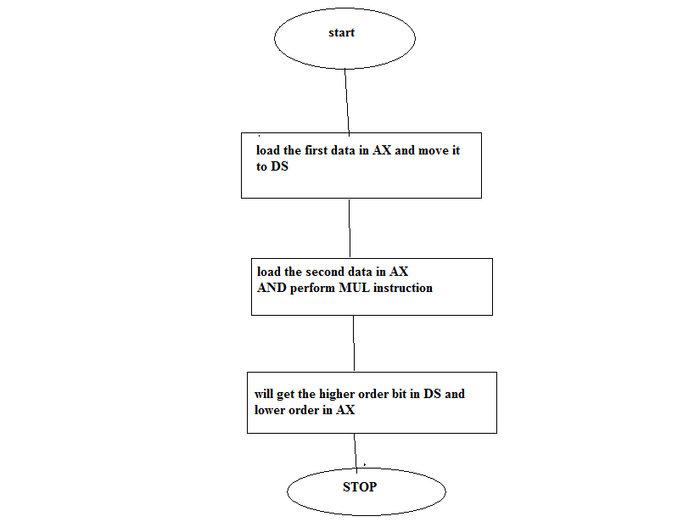

PROGRAM:-
MOV AX,BH;copy the data into AX
MOV DS,AX;move to DS
MOV AX,CH; copy second data to AX
MUL DS;multiply the numbers
END

Q19. Describe 80836 flag registers with significance of each bit .how does it differ from 8086 flag registers?
Explain functions of debug register? The 32-bit register flags register EFLAG is an extension of the 16-bit flag register in 8086 and 80286. The low-order 16 bits of EFLAGS are named FLAGS for compatibility with older 8086 and 80286 code. There are three basic groups of flags, status flags, control flags and the system flags. The flags are as follows:
The status flags used by application programmers are CF, PF, AF, ZF, SF, and OF. These flags hold the results of various instructions that are then used by later instructions.
DF, IF and TF are the control flags of 80286. These flags control the processor actions or action of certain instructions.
System flags in EFLAG are RF, NT, IOPL and VM.

Intel Reserved | VM | RF | 0 | NT | IOPL | OF | DF | IF | TF | SF | ZF | 0 | AF | 0 | PF | 1 | CF

31 17 16 15 14 13 12 11 10 9 8 7 6 5 4 3 2 1 0

RF: Resume flag is used with debug register break pointer. It is checked at the starting of every instruction cycle and if it is set, the debug fault can be ignored during that instruction cycle.

80386 provide eight debug registers, DR₀-DR₇ for hardware debugging. These registers contain Break point addresses (BPA) which are constantly compared with address generated by the program. If a match occurs, the 80386 will cause Type1 interrupt, if detected by debug registers DR₆ and DR₇.

DR₀
Linear Break Point Address
Linear Break Point Address
Linear Break Point Address
Linear Break Point Address
Intel Reserved
Intel Reserved
Break Point Status
Break Point Control

DR₁

DR₂

DR₃

DR₄

DR₅

DR₆

DR₇
It also provides two test registers TR₆ and TR₇, used to test the TLB (Transition look aside buffer). The TLB is used with paging unit and it holds 32 most commonly used address translations and reduces the memory reads. The test register TR₆ holds the tag field (Linear address) of the TLB, and TR₇ holds the physical address of TLB.
31 12
Linear address | Attributes
Physical Address | Attributes

Q20 ( a ) Explain the addressing modes supported by 80386.

Absolute:
+----+------------------------------+
|jump| address |
+----+------------------------------+

(Effective PC address = address)
The effective address for an absolute instruction address is the address parameter itself with no modifications.
+----+------------------------------+
|jump| offset | jump relative
+----+------------------------------+

(Effective PC address = next instruction address + offset, offset may be negative)

Register indirect
+-------+-----+
|jumpVia| reg |
+-------+-----+

(Effective PC address = contents of register 'reg')
The effective address for a Register indirect instruction is the address in the specified register. For example, (A7) to access the content of address register A7.
The effect is to transfer control to the instruction whose address is in the specified register.

sequential execution
+------+
| nop | execute the following instruction
+------+

(Effective PC address = next instruction address)
The CPU, after executing a sequential instruction, immediately executes the following instruction.
skip
+------+-----+-----+
|skipEQ| reg1| reg2| skip the following instruction if reg1=reg2
+------+-----+-----+

(Effective PC address = next instruction address + 1)
Skip addressing may be considered a special kind of PC-relative addressing mode with a fixed "+1" offset. Like PC-relative addressing, some CPUs have versions of this addressing mode that only refer to one register ("skip if reg1==0") or no registers, implicitly referring to some previously-set bit in the status register. Other CPUs have a version that selects a specific bit in a specific byte to test ("skip if bit 7 of reg12 is 0").
Unlike all other conditional branches, a "skip" instruction never needs to flush the instruction pipeline.

Register
+------+-----+-----+-----+
| mul | reg1| reg2| reg3| reg1 := reg2 * reg3;
+------+-----+-----+-----+
This "addressing mode" does not have an effective address and is not considered to be an addressing mode on some computers.
In this example, all the operands are in registers, and the result is placed in a register.

Base plus offset, and variations
+------+-----+-----+----------------+
| load | reg | base| offset | reg := RAM[base + offset]
+------+-----+-----+----------------+

(Effective address = offset + contents of specified base register)

Immediate/literal
+------+-----+-----+----------------+
| add | reg1| reg2| constant | reg1 := reg2 + constant;
+------+-----+-----+----------------+
This "addressing mode" does not have an effective address, and is not considered to be an addressing mode on some computers.
The constant might be signed or unsigned. For example move.l #$FEEDABBA, D0 to move the immediate hex value of "FEEDABBA" into register D0.

Implicit
+-----------------+
| clear carry bit |
+-----------------+
The implied addressing mode[1], also called the implicit addressing mode[2], does not explicitly specify an effective address for either the source or the destination (or sometimes both).
Either the source (if any) or destination effective address (or sometimes both) is implied by the opcode.
Implied addressing was quite common on older computers (up to mid-1970s). Such computers typically had only a single register in which arithmetic could be performed -- the accumulator. Such accumulator machines implicitly reference that accumulator in almost every instruction. For example, the operation <a := b + c;> can be done using the sequence <load b; add c; store a;> -- the destination (the accumulator) is implied in every "load" and "add" instruction; the source (the accumulator) is implied in every "store" instruction.

Absolute/Direct
+------+-----+--------------------------------------+
| load | reg | address |
+------+-----+--------------------------------------+

(Effective address = address as given in instruction)
This requires space in an instruction for quite a large address. It is often available on CISC machines which have variable-length instructions, such as x86.
Some RISC machines have a special Load Upper Literal instruction which places a 16-bit constant in the top half of a register. An OR literal instruction can be used to insert a 16-bit constant in the lower half of that register, so that a full 32-bit address can then be used via the register-indirect addressing mode, which itself is provided as "base-plus-offset" with an offset of 0.

Indexed absolute
+------+-----+-----+--------------------------------+
| load | reg |index| address |
+------+-----+-----+--------------------------------+

(Effective address = address + contents of specified index register)
This also requires space in an instruction for quite a large address. The address could be the start of an array or vector, and the index could select the particular array element required. The processor may scale the index register to allow for the size of each array element.

Base plus index
+------+-----+-----+-----+
| load | reg | base|index|
+------+-----+-----+-----+

(Effective address = contents of specified base register + contents of specified index register)
The base register could contain the start address of an array or vector, and the index could select the particular array element required. The processor may scale the index register to allow for the size of each array element. This could be used for accessing elements of an array passed as a parameter.

Base plus index plus offset
+------+-----+-----+-----+----------------+
| load | reg | base|index| offset |
+------+-----+-----+-----+----------------+

(Effective address = offset + contents of specified base register + contents of specified index register)
The base register could contain the start address of an array or vector of records, the index could select the particular record required, and the offset could select a field within that record. The processor may scale the index register to allow for the size of each array element.

Scaled
+------+-----+-----+-----+
| load | reg | base|index|
+------+-----+-----+-----+

(Effective address = contents of specified base register + scaled contents of specified index register)
The base register could contain the start address of an array or vector, and the index could contain the number of the particular array element required.
This addressing mode dynamically scales the value in the index register to allow for the size of each array element, e.g. if the array elements are double precision floating-point numbers occupying 8 bytes each then the value in the index register is multiplied by 8 before being used in the effective address calculation. The scale factor is normally restricted to being a power of two, so that shifting rather than multiplication can be used.
[edit] Register indirect
+------+-----+-----+
| load | reg | base|
+------+-----+-----+

(Effective address = contents of base register)

Register autoincrement indirect
+------+-----+-------+
| load | reg | base |
+------+-----+-------+

(Effective address = contents of base register)

Autodecrement register indirect
+------+-----+-----+
| load | reg | base|
+------+-----+-----+

(Effective address = new contents of base register)

Memory indirect
Any of the addressing modes mentioned in this article could have an extra bit to indicate indirect addressing, i.e. the address calculated using some mode is in fact the address of a location (typically a complete word) which contains the actual effective address.
Indirect addressing may be used for code or data. It can make implementation of pointers or references or handles much easier, and can also make it easier to call subroutines which are not otherwise addressable. Indirect addressing does carry a performance penalty due to the extra memory access involved.

PC-relative
+------+------+---------+----------------+
| load | reg1 | base=PC | offset | reg1 := RAM[PC + offset]
+------+------+---------+----------------+

(Effective address = PC + offset)
The PC-relative addressing mode is used to load a register from a "constant" stored in program memory a short distance away from the current instruction. It can be seen as a special case of the "base plus offset" addressing mode, one that selects the program counter (PC) as the "base register".

Q20.(b). Explain the addition features in pentium processor.

The Intel Pentium family
Produced From 1993 to 1999
Common manufacturer(s) Intel
Max. CPU clock 60 MHz to 300 MHz
FSB speeds 50 to 66
Min. feature size 0.8µm to 0.25µm
Instruction set x86
Microarchitecture P5
Cores 1
Socket(s) Socket 4, Socket 5, Socket 7
Core name(s) P5. P54, P54CS, P55C, Tillamook

Superscalar architecture - The Pentium has two datapaths (pipelines) that allow it to complete more than one instruction per clock cycle. One pipe (called U) can handle any instruction, while the other (called V) can handle the simplest, most common instructions. Some RISC-proponents argued that the "complicated" x86 instruction set would probably never be implemented by a tightly pipelined microarchitecture, much less by a dual pipeline design. The 486 and the Pentium demonstrated that this was indeed possible and feasible.
64-bit external databus width - This doubles the amount of information read or written on each memory access. This doesn't mean that the Pentium can execute 64-bit applications; its main registers are still 32 bits wide.
Faster floating point unit.
MMX instructions (later models only) - A basic SIMD instruction set extension designed for use in multimedia applications.

Pentium architecture chips offered just under twice the performance of a 486 processor per clock cycle. The fastest Intel 486 parts were almost as powerful as a first-generation Pentium, and the AMD Am5x86 was roughly equal to the Pentium 75.

The Pentium ("Classic") series were designed to run at over 100 million instructions per second (MIPS), [1] with the 75 MHz model running at 126.5 MIPS. [2]

